**CPSC542 Software Verification and Validation**

**Testing Report**

**By:**

**Shih-Li Hsu**

**Jennifer Wu**

**Gan Liu**

**CPSC 542**

**Fall, 2021**

**Instructor: Mr. Heckathorn**

**Department of Computer Science**

**California State University, Fullerton**

**Dec 15, 2021**

**Table of Contents**

1. **Abstract** **3**
2. **Team Member Introduction** **4**
3. **Project Introduction** **4**
4. **Test Plan** **6**
5. **Test Tool** **8**
6. **Product Introduction** **8**
7. **Conclusion 9**

# **Abstract**

The implementation of software measurement and software testing is considered one of the most important parts of the software development cycle nowadays. The software development process contains different steps. From the documentation to the design program, to testing and maintenance can all be measured by implementing the software testing.

The primary purpose for this project is to create a testing method to evaluate the SWAGLABS website. The main structure will be using the selenium automated testing to test the SWAGLABS website. After all the software measurements have been implemented. Evaluate the test results and analyze the outcome to provide a better software system of the project.

# **Team Member Introduction**

Below are our team members’ introduction.

Shih-Li Hsu (hsushihli@gmail.com)

Jennifer Wu (chihyi1126@csu.fullerton.edu)

Gan Liu (lgvincent@csu.fullerton.edu)

# **Project Introduction**

The objective of this project is to test if the function of the SWAGLABS website is satisfied for the client side or not. In this project, our working process is by using Selenium to test the operation of SWAGLABS. Selenium is a popular automation testing tool in the industry.

Automation Testing is the use of software separate from the software being tested to control the execution of tests and the comparison of actual outcomes with predicted outcomes.

Test automation can automate some repetitive but necessary tasks in a formalized testing process already in place, or perform additional testing that would be difficult to do manually. Test automation is critical for continuous delivery and continuous testing.

# **Test Plan**

3.1 Test plan identifier

CPSC 542 Group Project Test Plan

3.2 Introduction

This test plan is for testing if all functions in SWAGLABS project will be works correctly.

3.3 Items to be tested

The URL being tested:https://www.saucedemo.com/

Unit 1 Testing: Login.

Unit 2 Testing: Add items.

Unit 3 Testing: Shopping Cart.

3.4 Features to be tested

To display the result message in Selenium.

3.5 Approach

Automatic test.

3.6 Pass/fail criteria

Pass criteria: The test result is consistent with the expected result.

Fail criteria: Compile fail.

The test result is inconsistent with the expected result.

3.7 Suspension and resumption criteria

Suspension criteria: The end of a workday,or critical defects found.

Resumption criteria: The next morning of a workday.

3.8 Test deliverables

Automatic test cases.

3.9 Test environment

PC with windows 10 or Ubuntu 20.0x; Mac with MacOS 10.15.7

Github. Google chrome.

3.10 Staffing and training needs

Educational background or training of software testing.

3.11 Scheduling

10/25/2021, open source code received, all tests are designed.

11/01/2021, establish the testing plan.

11/15/2021, all tests are completed and recorded.

3.13 Risks and contingencies

Open source code is not completed as expected

Tight delivery deadline

3.14 Testing costs

Costs of planning and designing the tests: $360.00

Costs of acquiring the hardware and software necessary for the tests: $530.00

Costs to support the test environment: $0.00

Costs of executing the tests: $500.00

Costs of recording and analyzing test results: $400.00

Total: $1790.00

3.15 Approval Status:

Approved.

# **Test Tool**

In this project, we used Selenium as our testing tool.Selenium is a free (open-source) automated testing framework used to validate web applications across different browsers and platforms.

It allows multiple programming languages like Java, C#, Python etc to create Selenium Test Scripts. Testing done using the Selenium testing tool is usually referred to as Selenium Testing.

It is not just a single tool but a suite of software, each piece catering to different Selenium QA testing needs of an organization. Here is the list of tools:

* Selenium Integrated Development Environment (IDE)
* Selenium Remote Control (RC)
* WebDriver
* Selenium Grid

The advantage of Selenium are:

* Selenium is an Open Source Software.
* Selenium supports various programming languages to write programs (Test scripts)
* Selenium supports various operating systems (MS Windows, Linux, Macintosh etc...)
* Selenium supports various Browsers (Mozilla Firefox, Google Chrome, IE, Opera, Safari etc)
* Selenium supports Parallel Test Execution.
* Selenium uses fewer Hardware resources.

The disadvantage of Selenium are:

* No reliable Technical Support from anybody.
* It supports Web-based applications only.
* Difficult to use, takes more time to create Test cases.
* Difficult to Setup Test Environment when it compares to Vendor Tools like UFT, RFT, SilkTest etc.

# **Product Introduction**

SWAGLABS is an online shopping platform. The main functions include guests logging in with their account and password, buying products and adding them to the shopping cart, clicking the shopping cart button and viewing the selected products, inquiries and changes.

1. **Test Result**

The test result shows the error from the user interface of selenium. The error from the selenium interface shows that it is trying to find the css with the action called data-test login button. The results are failed and implicit wait times out after 30000ms. This specific test case ended with 1 error.

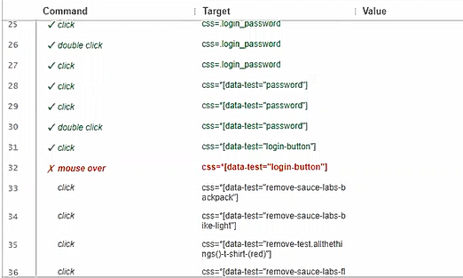

The error is called mouse over, the mouseover and mouseout effects is considered an important problem. It is when doing javascript effects. We often encounter the problem of mouseover and mouseout appearing multiple times when the mouse slides inside an element.

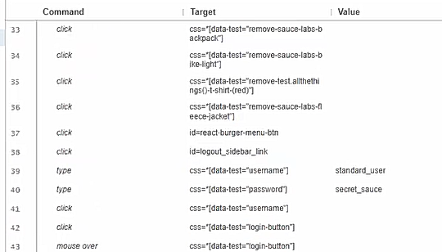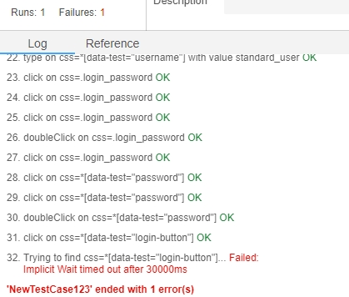

1. **Conclusion**

In summary, this test is approved. The basic functions which include login system to identify valid or invalid of account and password, select product item, add items into shopping cart, click shopping cart button, display shopping cart and other functions are all approved.

The only test which fails is the mouseover function. This test does not affect the overall website operation. We will fix and retest the website again in the future..